WHAT’S GOING ON?

July
4 Independence Day
9-13 Youth Camp – Highland Lakes
12 Senior Adult Fellowship – 10 am
14 Local Mission Project 15 Business Meeting
26 Senior Adult Fellowship – 10 am
29-Aug 3 VBS
August
29-Aug 3 VBS
9 Senior Adult Fellowship – 10 am
19 Business Meeting
23 Senior Adult Fellowship – 10 am

September
9 Lord’s Supper
9-16 Week of Prayer for Texas Missions
Mary Hill Davis Offering
13 Senior Adult Fellowship – 10 am
15 Local Mission Project
15 Turnipseed Reunion
16 Business Meeting
23 Senior Adult Fellowship – 10 am
26 See You at the Pole
27 Senior Adult Fellowship – 10 am
Dear Church Family,

Calling All People to “Work-It-On-Out”

JOIN US for workout classes. We meet Monday (6:30-7:30), Wednesday (6-7), & Thursday (6:30-7:30) in the fellowship hall. We have two groups… Tae Bo & Zumba for those who are slightly more fit & Richard Simmons for the rest of us!! We work at our own pace. No equipment needed. Come for fun, laughter, & fellowship!!

Journey Youth Camp

July 9th to 13th

Vacation Bible School

July 29th to August 3rd

Amazing Aviation Adventure

We still need a number of volunteers for all positions.
There is a sign-up sheet
in the Sunday School hallway on the bulletin board.
Please contact Cheryl Franklin or Patti Radford
for more information or to volunteer.

Just for Laughs

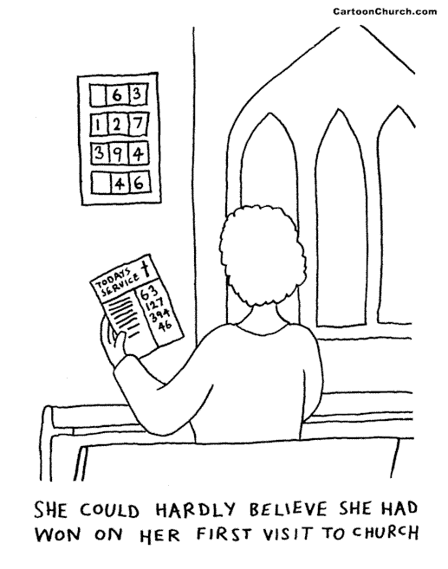

I am writing this newsletter article during a bittersweet time in my journey with Jesus Christ. After four plus years of serving you & the Lord at KSBC, God has called us to serve at First Baptist Church of Florence. My letter of resignation will be shared with the congregation on Sunday, July 1, & I will be preaching my last sermon here on July 15. I am looking forward to finishing my last work week here at Highland Lakes Camp as our male youth sponsor. We love the people at the church & will miss them dearly as we start a new chapter in our walk with God in Florence. We will always remember the people & the times we shared together.

I would like to share just a few of the things I have learned being your pastor…

IT IS HARD TO BE THE PASTOR OF A CHURCH! This experience has stretched me & grown me as a minister & as a follower of Christ. It’s hard to be neutral at times in relationships when our natural tendency is to go with the ones that you feel that give you the most support. I openly confess that I am insecure. In my personal insecurities, I feel that I pushed some people away & grew closer to others. That was not intentional but may have seemed so to some of you. My biggest regret is that some of you did not get to know the real me & my heart for the church & the body of Christ. If I hurt any of you along my journey, I’m sincerely sorry & would ask you to forgive me. I made many mistakes as your pastor, but I am so glad that His grace is sufficient for me & you & that He can cause all things to work together for good. I know that the Christian life is impossible to live fruitfully on our own. We need each other! God has gifted us with spiritual gifts for the building up & the encouragement of the church. When we, the church, are not involved in evangelism, reaching people with the gospel, fishing, everything falls into place where it should. When we aren’t fishing, evangelizing, then we are fighting. There are no perfect churches because there are no perfect people other than Jesus. KSBC has its share of problems, just like most other churches. There are no problems at this church that cannot be fixed with prayer & time. With the help & leading of the Holy Spirit, all things can be worked out within the church body. God has plans for this church as it continues to be a light in this community just as it has been for more than 150 years!

I thank God for the relationships that we have with you. I did not do everything right as the pastor of this church, but I know that God is bigger than any mistakes I made in the process of leading you. One thing I trust can be said about my ministry is that I served alongside you & did not just stand back & watch you lead without my participation. I thank God that KSBC is a church people who love the Lord, & that God is at work in & through your lives.

I also wanted to share some encouragement for you as you seek a new pastor & experience changes over the next few months:
- Keep seeking the face of God daily.
- Keep being salt & light everywhere you go.
- Keep growing & digging into the Word of God; I want to challenge you as I have over the past 4 years to be a self- feeder. You will be blessed as God speaks to you in your one on one time with Him.
- Keep using your gifts, talents & resources for Kingdom business.
- Find where God is working & join Him in His work.
- Develop an outreach ministry like GROW that will visit in people’s homes, write cards & letters of encouragement, concern, & love for people in need.
- Find more ways to minister out in the community away from the church building.
- Stay connected to Knobbs Springs Baptist Church.
- Keep serving & giving of your time, resources & your heart to the things of God. There will be new areas of service. Be one that is ready to step up & give all you have to God through serving.
- I have heard rumors of people leaving. Please don’t leave without seeing what part God may have for you to play during this transition time.
- If God called you to KSBC, make sure He has released you to go somewhere else.
- Work through challenges & issues together with a spirit of openness & prayer. If I have learned anything during my time here, I have learned the only way to truly see God work is to be open to seeing my part in any problem going on.

It has been a joy to serve you & to work along aside you the past four years.

In Christ,

Brother Mark 512-229-6555 ~ Txloves2fish@yahoo.com

